Name: Nithin Das CWID: 10422784 Date: 03/23/2020

BIA 672 Marketing Analytics

Assignment 1

HW 01:

Use income tax (income_byzip_pct) data and the following criteria to create ten (10) clusters of zip

codes for Virginia and identify clusters where “Kebab Shop” can open a new store

•

Pct of income in each category and hierarchical clustering methodology

•

Pct of income in each category and k-means clustering methodology

1. **KMeans clustering on Pct of Income**

List of Zip codes and corresponding clusters is shown in ‘***Part2 VA_CLUSTERS.pdf’***

Exploratory Data Analysis on the obtained clusters is shown in attached Python file ‘*Assignment 1_Clustering.ipynb*’.

The mean ***Return_pct*** values for each cluster shown below:

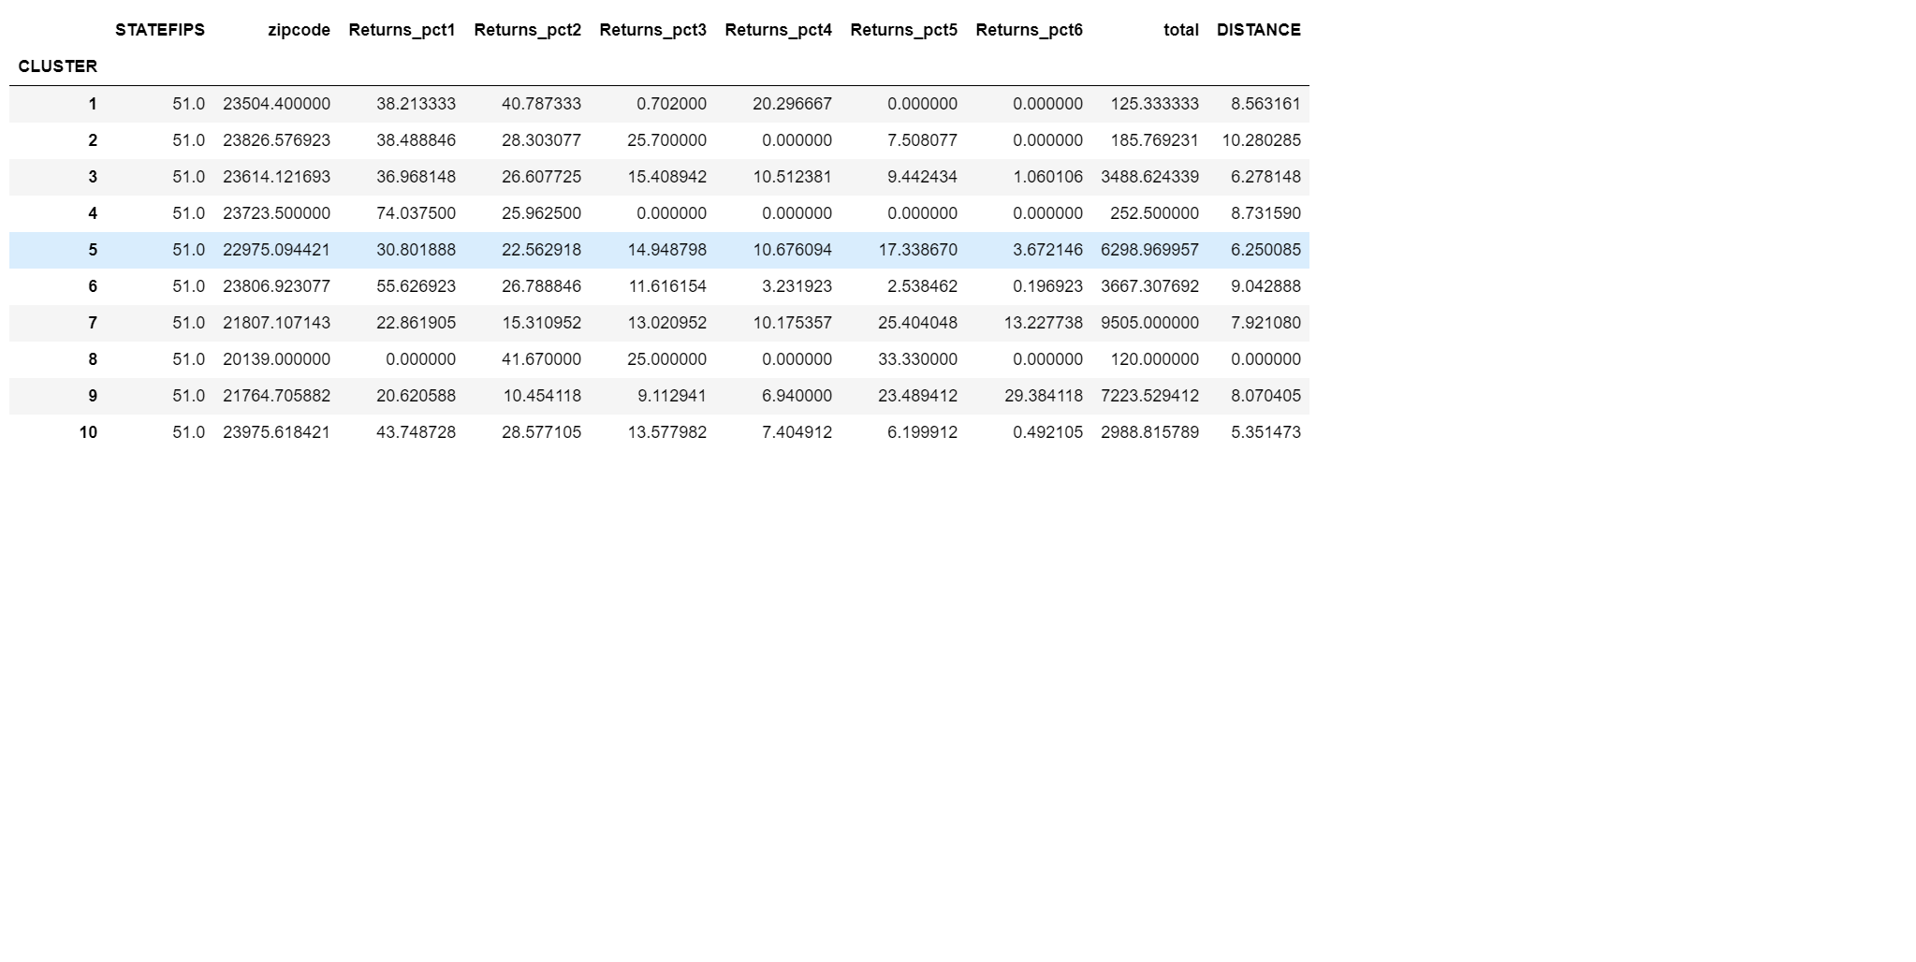

We want to select cluster where Returns_pct6 is higher, since the income is higher for the group. Higher income group is more likely to use Fast food restaurants.

**Returns_pct6 is higher for cluster 9, therefore all zip codes under cluster 9 is a good choice starting The Kebab Show.**

2. **Hclust on Pct of Income**

List of Zip codes and corresponding clusters is shown in ‘***Part1 HCLUST10.pdf’***

Cluster Summary is shown below:

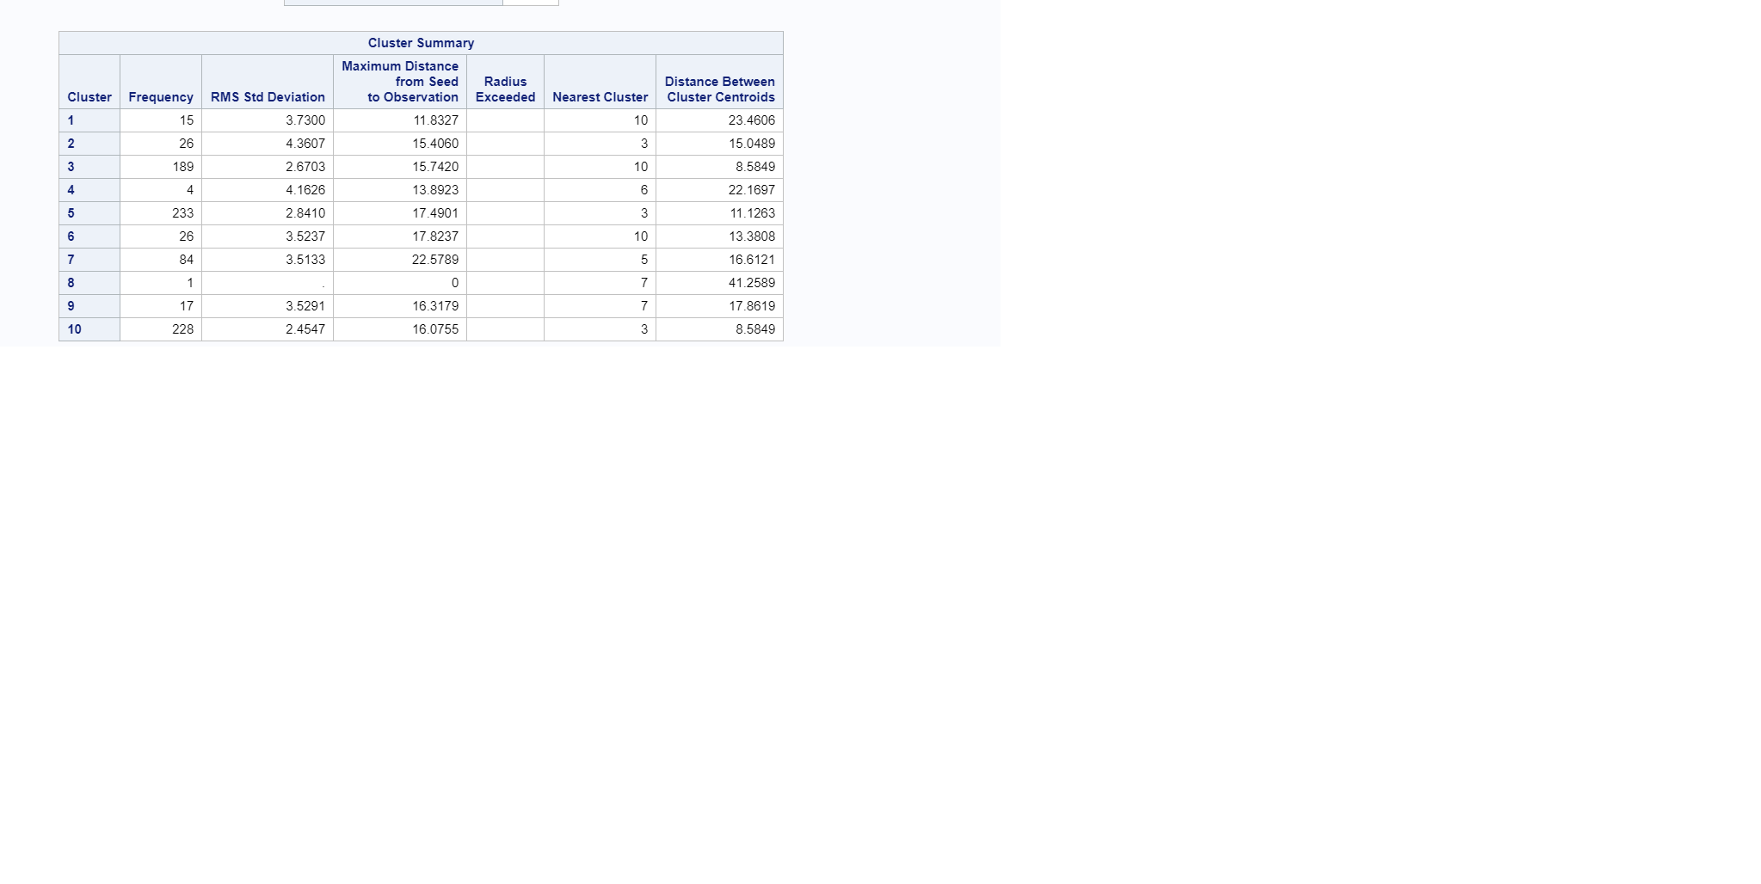

Cluster mean and standard deviation is shown below:

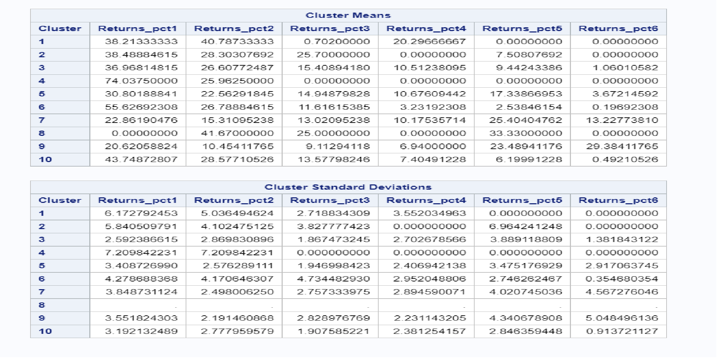

**All the zip codes under cluster 9 is a good choice starting The Kebab**